**Using the EMarketplace with new Oracle**

* Log into IProcurement
* In the Shop Tab choose Science Warehouse Hub

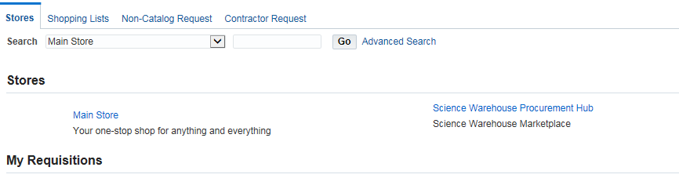

* This will take you into the EMarketplace

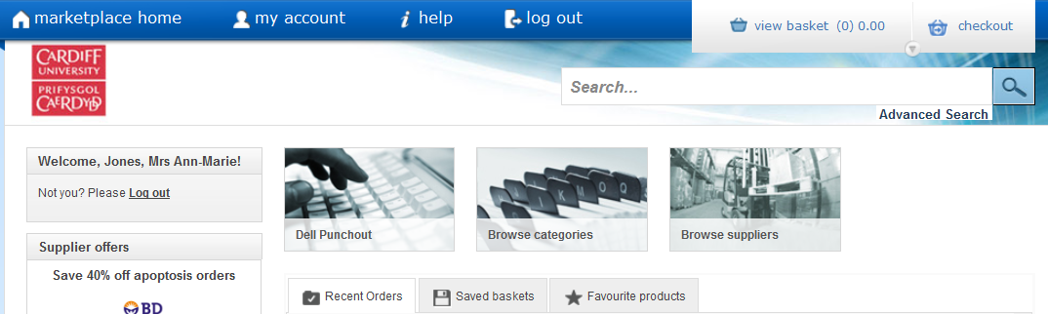

* Enter the Product code or item description in the empty field and select the search button
* You will then see a list of suitable products

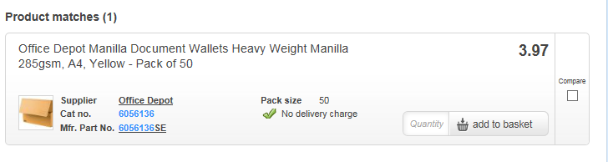

* Once you have found your product you are able to select the quantity required and Add to Basket
* If you require to add move items from the same supplier you will need to repeat the steps above and you will see these move to your Basket
* Review your Basket and select Checkout

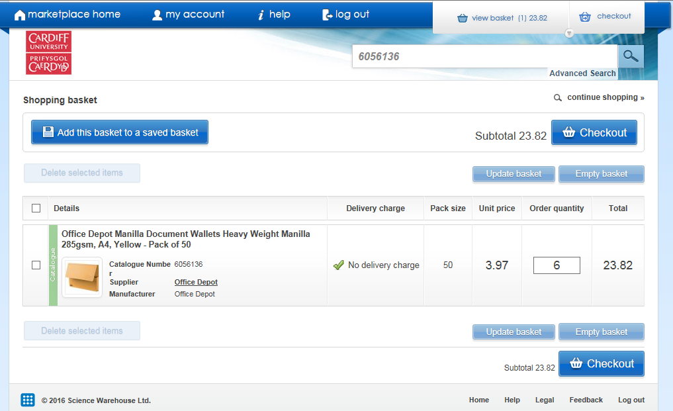

* This will take you back to the normal IProcurement checkout screen

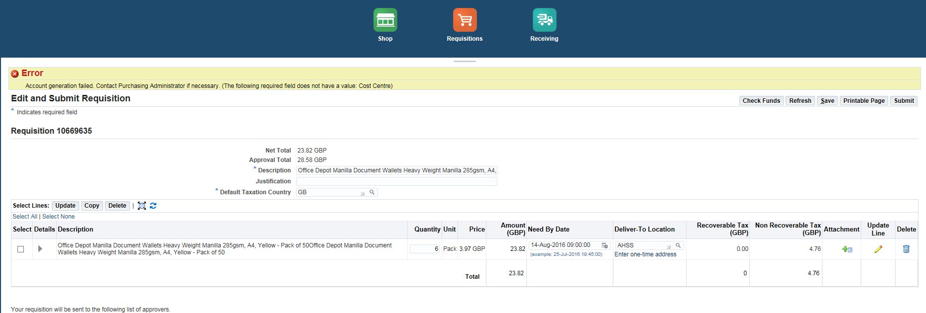

* Now click the Shopping Cart before doing anything else



* This will allow you to amend the Requestor and Deliver to Location
* You can also add the AH2016XXXX reference as you would normally



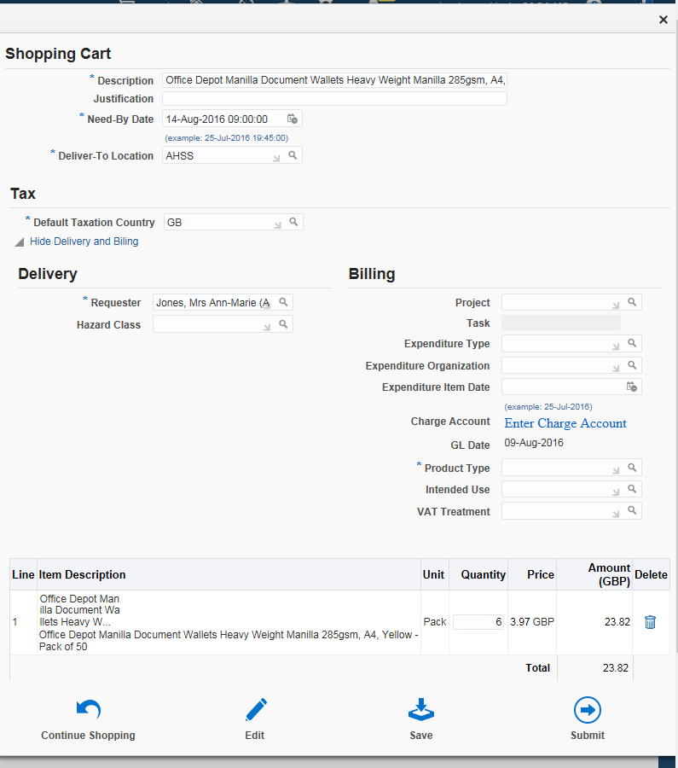

* Once you have made the changes you must enter Product type (Goods or Services then click Enter Charge Account

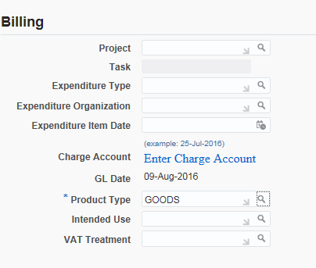

* You now must enter the relevant codes
* Tick the Select box and Update

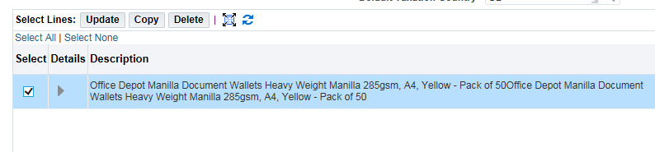

* You can now enter the Cost Centre/Analysis/Account Codes etc

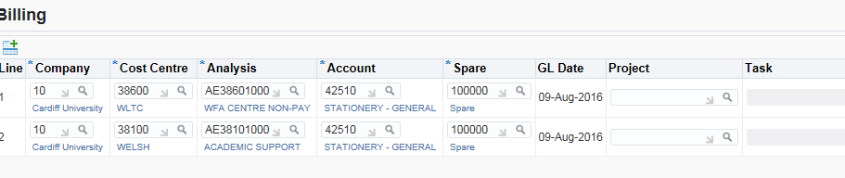

* If you have the same code for all lines ensure you tick the Apply this Cost Allocation box

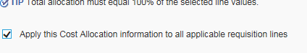

* Ensure you have selected the correct VAT, if the VAT is standard leave blank as system automatically selects this for you.
* Click Apply



* Click Check Funds or Refresh to update the system



* You may have a warning message to check funds, please speak to Finance Officer or Finance Manager if unsure
* Click Submit
* You may be asked to check funds again, if happy select Yes
* You will then get your Confirmation
* Go back to Kayako and update you ticket with the Requisition number and change status to In Progress

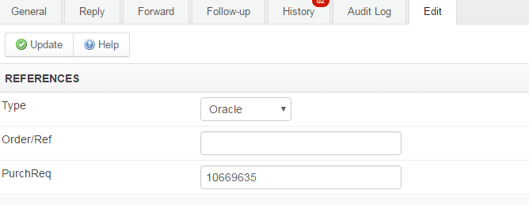



* Once approved, advise requestor in Kayako of order number, update ticket and close.