**Splitting a code on Oracle**

* Log onto IProcurement and shop as normal
* Once you get to Enter the Charge Account stage this is where you can add multiple codes
* Click the below symbol underneath billing to add as many lines as needed

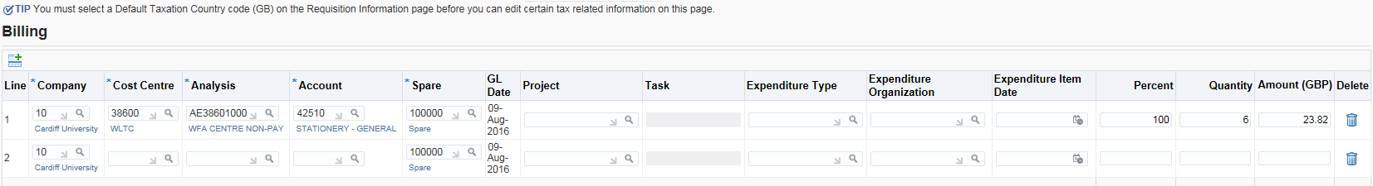

* Complete Line 1 as normal but on the far right hand side you can see the Percentage is 100%, the Quantity and Amount. You need to adjust to the required split for example:

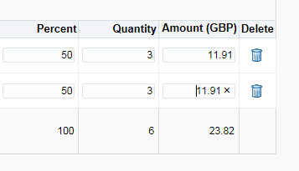

* Continue as normal