**Catering Requests**

Website: <http://www.onlinecatering.cardiff.ac.uk/KxWebCatering/Login.aspx?ReturnURL=/KxWebCatering/CurrentBookings.aspx>

Email Log on: [StruebigM@cardiff.ac.uk](mailto:StruebigM@cardiff.ac.uk)

Password: Ahsscater

Log on to the online system using Martyn’s email and password

Enter date, time, building and room

In Title section use the following naming convention: Kayako number, Name of Person catering is for and your initials i.e. K#1234 Martyn Struebig MS

Select Go

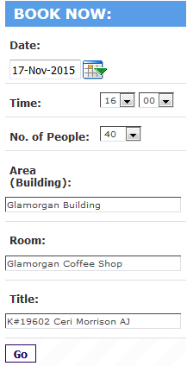

From the Menu choices choose the relevant option for example tea/coffee is in Beverages and can be in Crockery or in Biodegradable cups and you can choose tea/coffee on its own or with biscuits, pastries etc.

Choose the number required from the drop down and Add to Basket

It will then appear in your Shopping Basket

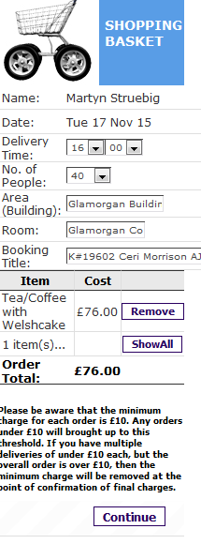

If this is all you need you can click Continue or make further choices from the Menu

You can then review your booking

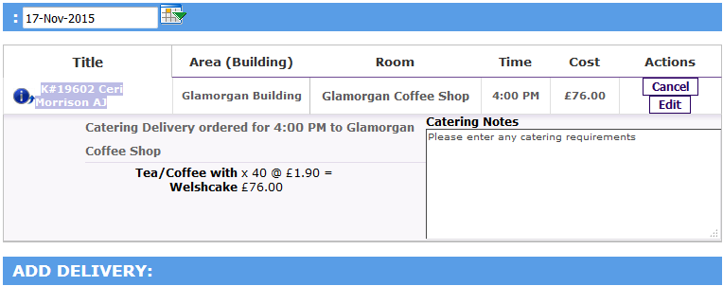

If you needed to add multiple times or dates rather than creating new bookings you can choose Add Delivery

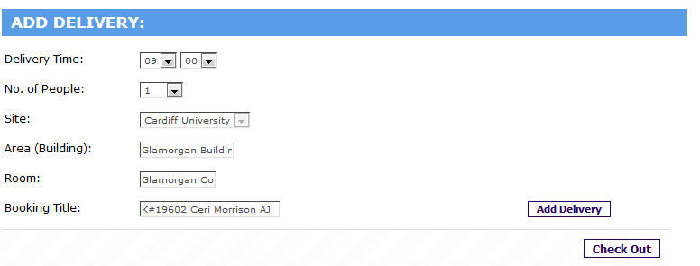

This will take you back to the Shopping Basket but you can amend times, buildings, number of persons – Please note you need to change the date, if needed, on the review section

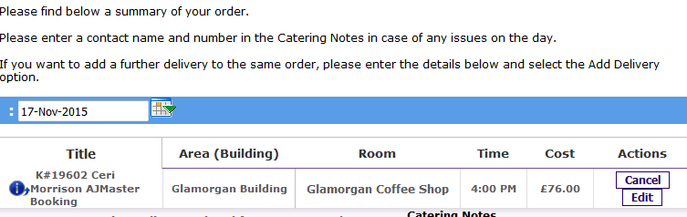

Once you have everything you need choose Check Out

You will be able to review the order again and add any dietary requirements

Enter the Cost Code, Analysis Code and Account Code (usually 46030)

If using a Project Code, the code goes in Cost Centre, Hospitality goes in the Analysis Code section and DI in the Account Code section

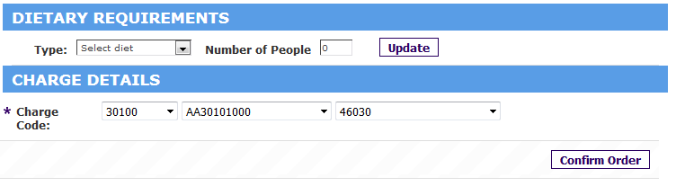

Choose Confirm Order

This will then generate a Booking Ref and an email of confirmation will go to AHSS-Finance.

Reply to the requestor via Kayako and forward on confirmation for them to check.

**Hints and Tips**

If Jugs of Juice are required they are not on the Menu but can be requested on the Catering Notes, same for Canapés, and any unusual requirements or alterations to menu choice i.e. bagels

Minimum spend £10.00

Waitress service currently £30 and must be requested in the notes

Carvery at Aberdare we usually choose two or three courses rather than one to give the diners a choice.

If dining at Aberdare Hall you will need to put at least one guests name in Catering note as a reservation.

Bar Meals in Aberdare Hall are not on menu but you would choose One Course Carvery at Aberdare Hall and add Bar Meals in Catering Notes

If the Analysis code does not work you will need to email [COA@cardiff.ac.uk](mailto:COA@cardiff.ac.uk) and they will update the code, this can take up to 24 hours to update on catering system.