Catering Requests

Website: http://www.onlinecatering.cardiff.ac.uk/KxWebCatering/Login.aspx?ReturnURL=/KxWebCatering/CurrentBookings.aspx
Email Log on: StruebigM@cardiff.ac.uk
Password: Ahsscater
Log on to the online system using Martyn’s email and password
Enter date, time, building and room
In Title section use the following naming convention: Kayako number, Name of Person catering is for and your initials i.e. K#1234 Martyn Struebig MS
Select Go
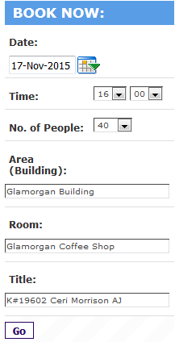
From the Menu choices choose the relevant option for example tea/coffee is in Beverages and can be in Crockery or in Biodegradable cups and you can choose tea/coffee on its own or with biscuits, pastries etc.
Choose the number required from the drop down and Add to Basket
It will then appear in your Shopping Basket
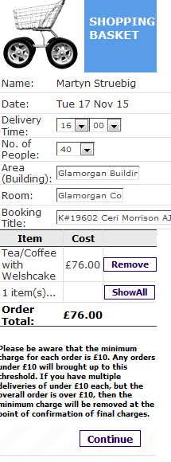
If this is all you need you can click Continue or make further choices from the Menu
You can then review your booking
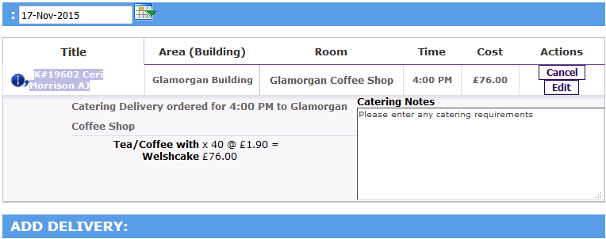
If you needed to add multiple times or dates rather than creating new bookings you can choose Add Delivery
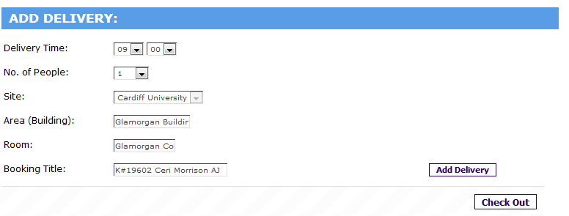
This will take you back to the Shopping Basket but you can amend times, buildings, number of persons – Please note you need to change the date, if needed, on the review section
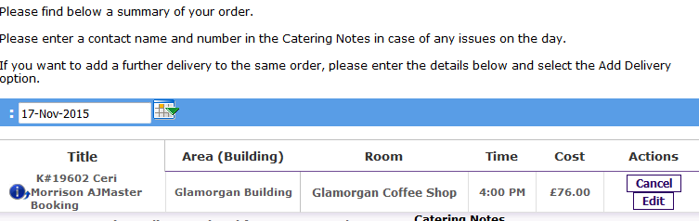

Once you have everything you need choose Check Out
You will be able to review the order again and add any dietary requirements
Enter the Cost Code, Analysis Code and Account Code (usually 46030)
If using a Project Code, the code goes in Cost Centre, Hospitality goes in the Analysis Code section and DI in the Account Code section

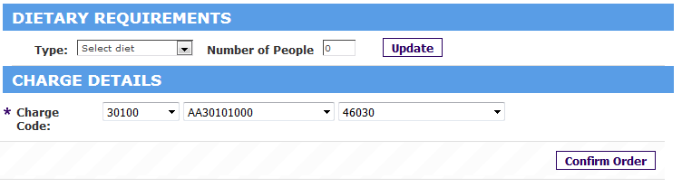
Choose Confirm Order
This will then generate a Booking Ref and an email of confirmation will go to AHSS-Finance.
Reply to the requestor via Kayako and forward on confirmation for them to check.

Hints and Tips
If Jugs of Juice are required they are not on the Menu but can be requested on the Catering Notes, same for Canapés, and any unusual requirements or alterations to menu choice i.e. bagels
Minimum spend £10.00
Waitress service currently £30 and must be requested in the notes
Carvery at Aberdare we usually choose two or three courses rather than one to give the diners a choice.
If dining at Aberdare Hall you will need to put at least one guests name in Catering note as a reservation.
Bar Meals in Aberdare Hall are not on menu but you would choose One Course Carvery at Aberdare Hall and add Bar Meals in Catering Notes
If the Analysis code does not work you will need to email COA@cardiff.ac.uk and they will update the code, this can take up to 24 hours to update on catering system.

