**Enterprise Car Hire System**

Website: <https://b2b.enterprise.co.uk>

Log on: [ahss-finance@cardiff.ac.uk](mailto:ahss-finance@cardiff.ac.uk)

Password: ahsscar57

Create a Reservation:

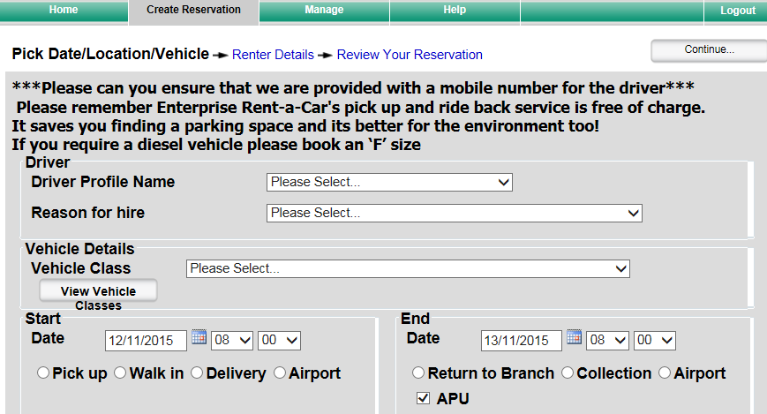

Choose Drive Profile, if not set up select (New Driver Profile)

Choose Reason for hire – should automatically fill in Daily Rental

You will need to choose a Vehicle class, if it has not been specified we normally pick D-Man

Choose Start Date and Time

Choose whether it is a Pick Up from Enterprise, Delivery (Home or Business – you will need to provide the address) or Airport (if it is an Airport we will need the flight details including flight number)

Choose End Date and Time

Choose whether it is a Return to Enterprise Branch, Collection (Home or Business – you will need to provide the address) or Airport (if it is an Airport we will need the flight details including flight number)

This will then generate an estimated cost in order to raise the PO

Keep the page open and switch to Oracle and raise order as normal. When raising the order number use separate lines for the Car Hire Rate, Delivery and Collection costs in case the hire is amended.

Once approved return to open page add PO, Department (AHSS Finance) and your name as Booker, you can also add any requests in the Notes section

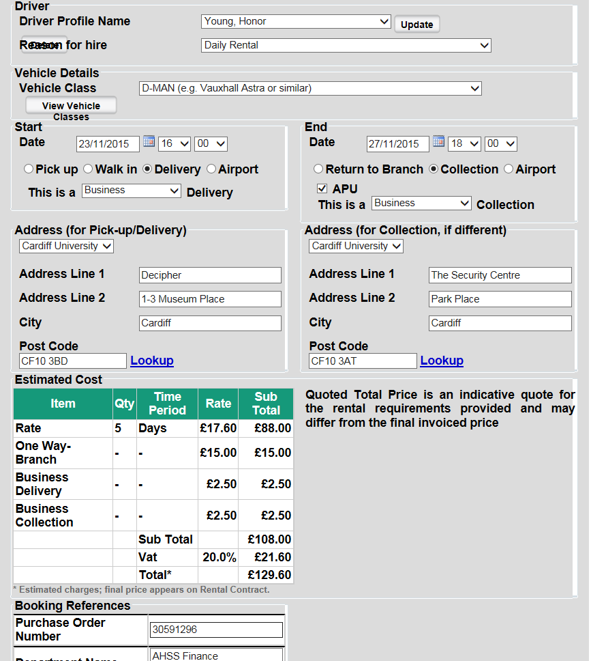

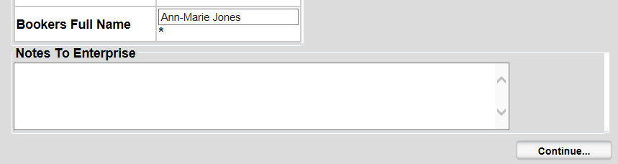

Choose Continue…

You will then be able to review this and if happy choose Book Now

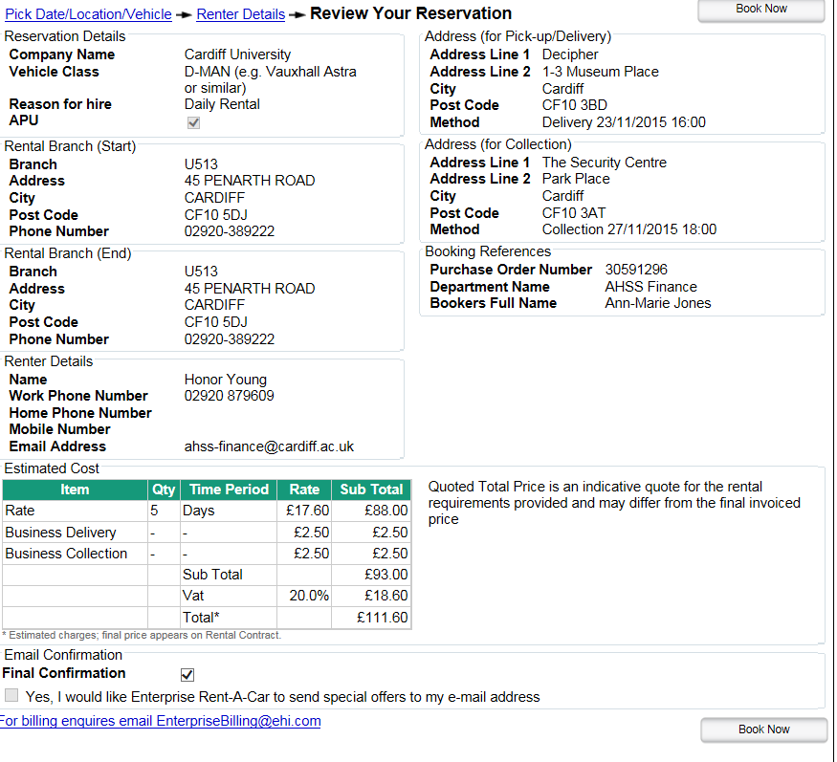

Return to Kayako and advise requestor.

An email will be sent to AHSS-Finance to confirm and will go into Oracle Orders To Do folder, you can merge this to the original ticket.