**Internal Trade Order on Oracle**

* Log into IProcurement
* Choose Non-Catalog Request

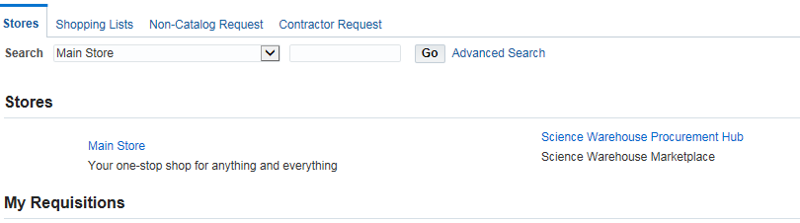

* Using the dropdown selection on Request Type choose the relevant Internal Trade supplier

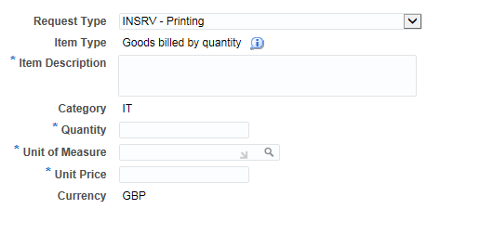

* This has automatically filled in the Category and Supplier Details for you
* Enter Description
* Enter Quantity Required
* Enter the Unit of Measure for example “EACH” or “PACK OF 250”
* Enter Unit Price

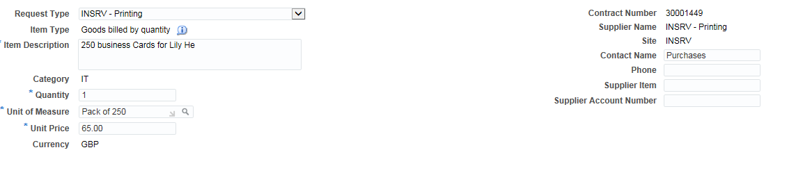

* Add to Cart



* If you do need to add anything else to the order choose View Cart and Checkout

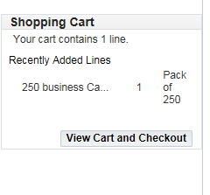

* Add Naming Convention in Description field i.e. AH20160808, A, Julie Mein, K#48688, 250 business Cards for Lily He
* Change Requestor
* Change Deliver To Location
* Choose Enter Charge Account

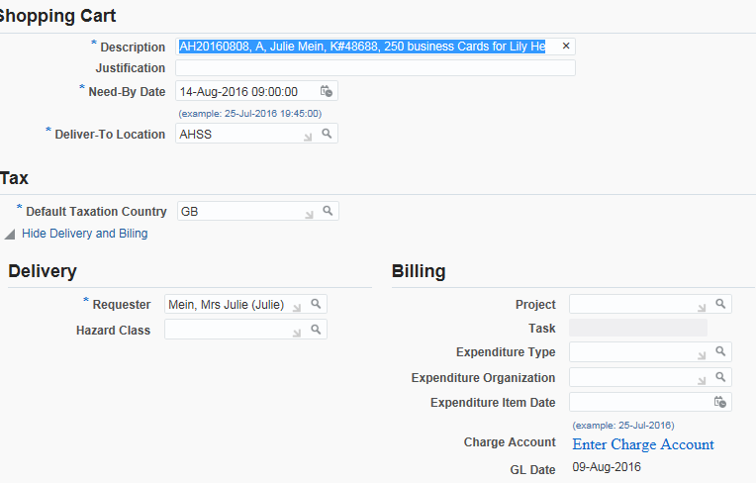

* To add the Codes add a tick to the Select Box and choose Update

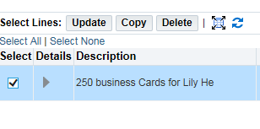

* Add codes

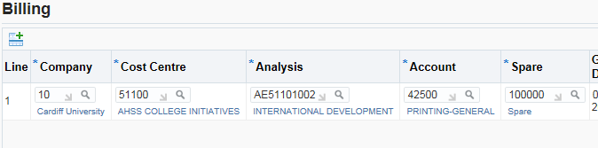

* If more than one line and you want to keep the same code click the Apply this Cost Allocation box

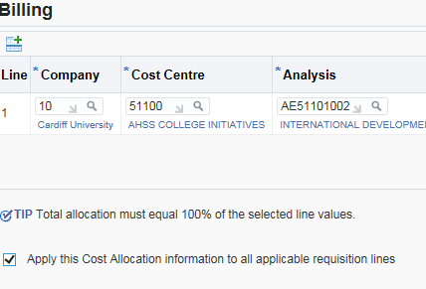

* Once finished choose Apply



* Click Check Funds or Refresh to update the system

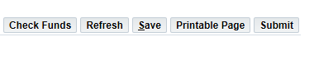

* You may have a warning message to check funds, please speak to Finance Officer or Finance Manager if unsure
* Click Submit
* You may be asked to check funds again, if happy select Yes
* You will then get your Confirmation
* Go back to Kayako and update you ticket with the Requisition number and change status to In Progress

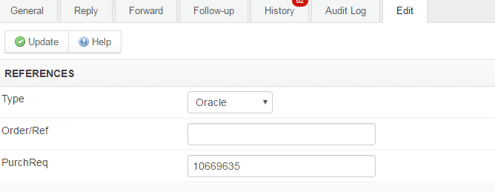



* Once approved, advise requestor in Kayako of order number, update ticket and close.