Open database

On bottom left hand side click New Reference button

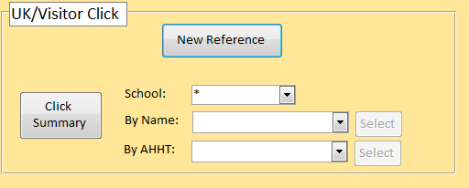

This opens a new screen within the database

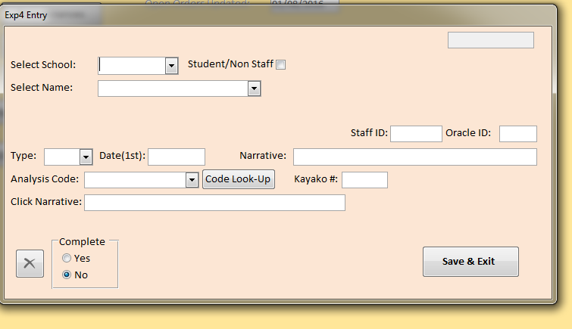

Choose School (if staff the name should be in the select drop down) if not tick Student/Non Staff and enter names manually

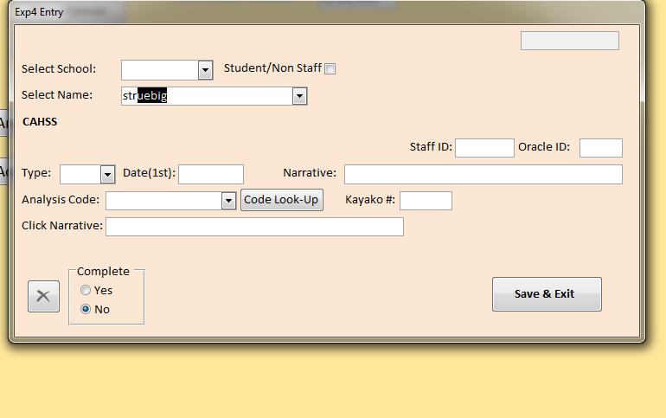

Choose type from Dropdown

Enter date of travel (1st day)

Add brief description i.e. Cardiff Central to Swansea

Add correct code or Project

Add Kayako number

Tick Complete

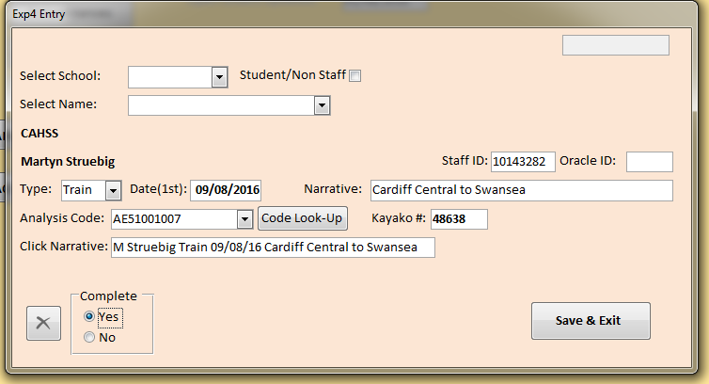

Click Save & Exit and you will be given your reference number

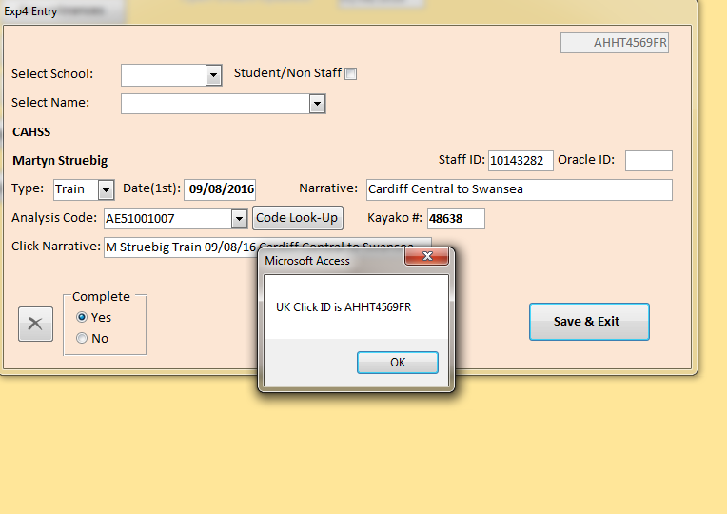

Click OK and exit