

**HOTELS & ACCOMMODATION IN WALES 2016**

**N - Z**

**This list is purely for information for HEPCW members and our visitors to Wales - it is NOT a formal agreement.**

**Therefore if you book with any of the hotels listed, you must ensure that you comply with your own organisation's purchasing procedures.**

**The rates quoted are agreed between HEPCW and the hotel, but are likely to reflect any rate agreed through the Crown Commercial Services (Government Rates). Rates quoted include breakfast, unless otherwise stated.**

**It is recommended that visitors check for any special rates available prior to requesting University/Government rates, as these are sometimes a better deal, especially during quiet periods. However, during busy periods, all Hotels reserve the right to revert to full rates.**

**Listed below are the hotels included within this arrangement – please click on the hotel name of your choice or scroll down to view all. You can also view the quick comparison chart.**

**CARDIFF & AREA :**

Park Plaza Hotel – Vale Resort, Hensol – St. David’s Hotel & Spa

**SWANSEA:**

Swansea Marriott

**PLEASE NOTE :**

All rates are offered subject to availability – please check before confirming your booking  
All hotel rates quoted include breakfast, unless otherwise stated. Prices are per night.

**HOTEL:** Park Plaza Hotel **Tel:** 029 2011 1111

Greyfriars Road **Reservations:** 029 2011 1100

Cardiff, CF10 3AL **Conference:** 029 2011 1123 **Contact:** Caroline Sims

**Email:** [ppcres@parkplazahotels.co.uk](mailto:ppcres@parkplazahotels.co.uk)

**Web:** [www.parkplazacardiff.com](http://www.parkplazacardiff.com)

**Owner**  Park Plaza  **No. of rooms:** 129

**Rating:** 4 star **No. of conference rooms:** 11

**Quote Ref:** University

**DETAILS:**

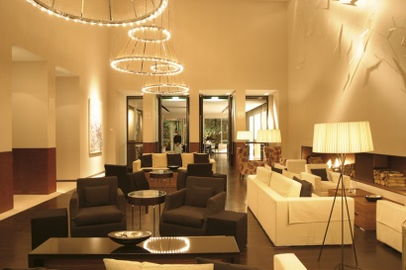The Park Plaza is a deluxe 4 star hotel located in the heart of the city centre on Greyfriars Road, opposite City Hall and within easy walking distance to Cardiff University campuses, including Park Place, Newport Road, Corbett Road, Cathays Park and Senghenydd Road. Also within walking distance of the University of South Wales Atrium and a short taxi ride to Cardiff Metropolitan University’s compuses.

**Free** WiFi, **free** use of health club facilities and full Welsh breakfast included in all rates. Laguna Kitchen & Bar uses locally sourced Welsh produce and has won Restaurant of the Year. Outside balcony for dining.

**FACILITIES:**

|  |  |
| --- | --- |
| * En-suite with air conditioning * Tea/Coffee facilities * TV and complimentary WiFi | * NCP car park opposite – 20% discount * Full Leisure facilities, including 20 metre pool, 80 station gym, steam room & spa bath. 8 Elemis treatment rooms |

Disability access: Fully compliant

|  |  |  |  |
| --- | --- | --- | --- |
|  | **Price inc. VAT** | **Price per room / person?** | **Mon- Sun?** |
| **ROOM RATES:** |  |  |  |
| Single Room | £99.00 | Per room | Sun - Thurs |
| Double room | £109.00 | Per room | Sun – Thurs |
| Double room – single occupancy | £99.00 | Per room | Sun - Thurs |
| Executive Double for single occ | £129.00 | Per room | Sun – Thurs |
| Executive Double for double occ | £139.00 | Per room | Sun - Thurs |
| **DELEGATE RATES:** |  |  |  |
| Day Delegate | £32.00 | Per person |  |
| 24hr Delegate | £165.00 | Per person |  |

Day rate includes wifi, main room hire, unlimited tea and coffee, two course luncheon, OHP, screen, flipchart and LCD projector. Natural daylight in most meeting rooms.

24hr rate include the above plus 3 course TDH dinner, room and full breakfast.

**HOTEL:** St. David’s Hotel & Spa **Tel:** 07507 554009

Havannah Street **Reservations:** 029 2045 4045

Cardiff, CF10 5SD **Conference:** 029 2045 4045 **Contact:** Laura Lewis

**Email:** [laura.lewis@principal-hayley.com](mailto:laura.lewis@principal-hayley.com)

**Web:** <http://www.principal-hayley.com>

**Owner :** Principal Hayley **No. of rooms:** 142

**Rating:** 5 star **No. of conference rooms:** 8

**Quote Ref:** Cardiff University

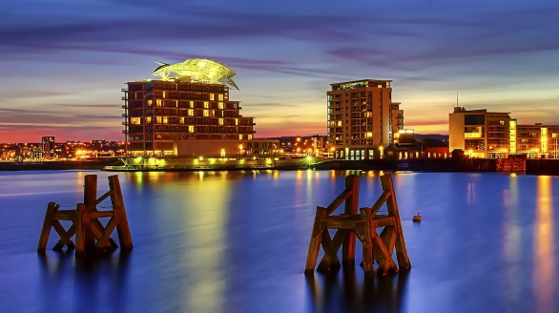**DETAILS:**

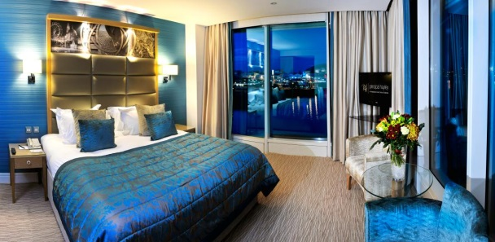Situated on the waterfront of Cardiff Bay, the St. David’s Hotel & Spa is a striking Cardiff landmark. Dynamic and contemporary in style, the building incorporates a glass-backed atrium from floor to ceiling, giving a vision of space and natural light. Hosts an on-site spa and restaurant as well as on-site parking. Cardiff International Airport is just 13 miles away, Cardiff Central Station within a short taxi ride or train ride from Cardiff Bay station (five minute walk from the hotel) and easy access to University campuses.

**FACILITIES:**

|  |  |
| --- | --- |
| * All bedrooms en-suite * Tea/Coffee/Ironing facilities * TV and WiFi * Full buffet breakfast * Fully compliant disability access | * Hotel car park with 55 spaces charged at £15 for 24hrs. Also NCP car park adjacent. * Full Leisure facilities, including pool, gym, hydro pool and spa treatments. * Business centre and Tempous at Tides Restaurant |

|  |  |  |  |
| --- | --- | --- | --- |
|  | **Price inc. VAT** | **Price per room / person?** | **Mon- Sun?** |
| **ROOM RATES:** |  |  |  |
| Double room – single occupancy | £89.00 | Per room | Sun – Thurs |
| Double room – double occupancy | £101.00 | Per room | Sun - Thurs |
| **DELEGATE RATES:** | From: |  |  |
| Day Delegate | £39.00 | Per person |  |
| 24hr Delegate | £149.00 | Per person |  |

University rates also include 20% discount off pre-booked spa treatments and food purchased in Tempuos at Tides (Sun-Thurs).

**HOTEL:** Swansea Marriott **Tel:** 01792 634866

Maritime Quarter **Reservations:** 01792 642020

Swansea, SA1 3SS **Conference:** 01792 642020

**Contact Name:** Vaness Walters

**Email:** [mhrs.swsdt.frontdesk@marriotthotels.com](mailto:mhrs.swsdt.frontdesk@marriotthotels.com) **Web:** [www.swanseamarriott.co.uk](http://www.swanseamarriott.co.uk)

**Owner**  Marriott Hotels International **No. of rooms:** 119

**Rating:** 4 star **No. of conference rooms:** 6

**Quote Ref:** University / Government rate

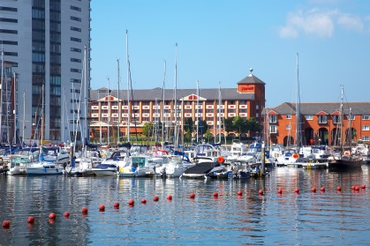**DETAILS:**

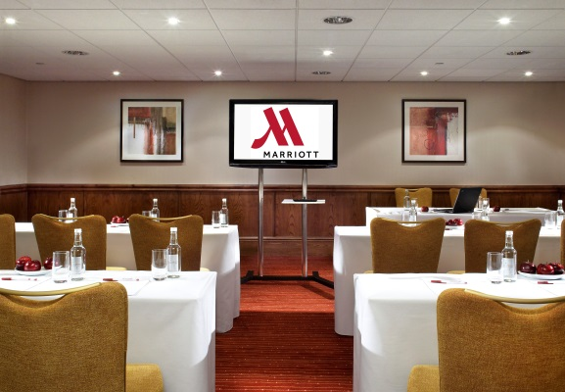In the bustling Maritime Quarter on the enchanting Swansea Bay, the Swansea Marriott Hotel captures the charm and beauty of its Gower peninsula surroundings. A gentle stroll to the city centre complete with its lively markets and attractions, surrounded by the very best of Wales' golf courses, a short distance from the Liberty Stadium and Ffos Las Racecourse, the Swansea Marriott Hotel has appeal for all. Experience a superior level of service and the warmest of Welsh welcomes. Our spacious guest rooms offer supreme comfort and functionality. Make use of your in-room workspace, before unwinding in our Leisure area, with mini gym, pool, whirlpool and sauna. The hotel restaurant serves local produce complimented with fine wine, which follows through to our extensive room service menu. The Swansea Marriott Hotel has an impressive Conference and Banqueting facility, complemented by expert catering. Whether you're on business or a relaxing break, the Swansea Marriott is the ideal venue.

**FACILITIES:**

|  |  |
| --- | --- |
| * All bedrooms en-suite * Tea/Coffee facilities * TV and WiFi | * Car park, complimentary on site * Full English breakfast * Full Leisure facilities |

Disability access: Fully compliant

|  |  |  |  |
| --- | --- | --- | --- |
|  | **Price inc. VAT** | **Price per room / person?** | **Mon- Sun?** |
| **ROOM RATES:** |  |  |  |
| Single Room | £99.00 | Per room | Y |
| Double room, single occupancy | £119.00 | Per room | Y |
| Double room | £119.00 | Per room | Y |
| Twin room (2 doubles) | £119.00 | Per room | Y |
| **DELEGATE RATES:** |  |  |  |
| Day Delegate |  | Per person |  |
| 24hr Delegate |  | Per person |  |

Please contact the hotel Conference Office to discuss your requirements and a full quote.

**HOTEL:**Vale Resort **Tel:** 01443 665808 Hensol Park **Reservations:** 01443 667800 Option 1Hensol  **Conference:** 01443 665808

Vale of Glamorgan, CF72 8JY **Contact Name:** Linda Taylor

**Owner**  Vale Resort  **No. of rooms:** 143

**Rating:** 4 star **No. of conference rooms:** 14

**Quote Ref:** Cardiff University

**DETAILS:**

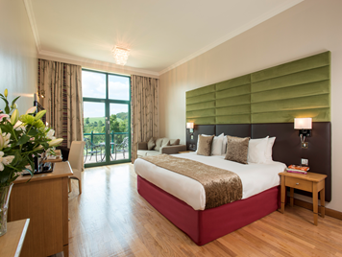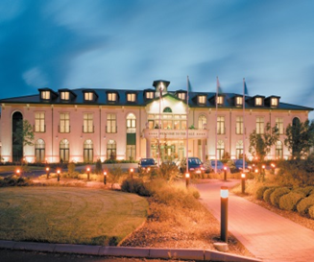Modern Country Hotel situated just a 5 minute drive from the M4 Motorway, junction 34. The Vale Resort has 14 multi-functional meeting rooms, 143 double or twin bedrooms for single or double occupancy. A fully equipped gym plus 20 metre pool, Wales’ largest Health Spa and 2 Championship Golf Courses. AA Rosette Restaurant. Charity balls and dinners for up to 400 people.

**Hensol Castle (see also Conference list) – to host exclusive meeting and events up to 200 people.**

**FACILITIES:**

|  |  |
| --- | --- |
| * All bedrooms en-suite, many with views * Award winning restaurant * 2 championship golf courses * 19 treatment room spa | * Extensive leisure facilities * Free onsite parking * Free wifi * Disability access – full compliant |

|  |  |  |  |
| --- | --- | --- | --- |
|  | **Price inc. VAT** | **Price per room / person?** | **Mon- Sun?** |
| **ROOM RATES:** |  |  |  |
| Double room, single occupancy | £80.00 | Per room | Y |
| Double/Twin Room | £90.00 | Per room | Y |
| **DELEGATE RATES:** |  |  |  |
| Day Delegate | £45 | Per person |  |
| 24hr Delegate | £145 | Per person |  |

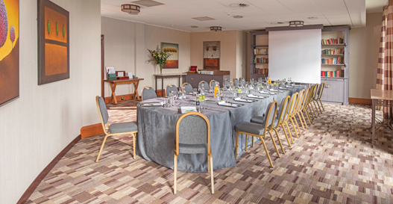**Day Delegate rate includes:**

Hire of main conference room

1 Serving of tea/coffee with Danish Pastries

Finger buffet served with tea/coffee

2 servings of tea/coffee with biscuits

Screen, flipchart and pens

Conference stationery & name cards

Cordials, mineral water, sweets

FREE parking

**24 Hour rate includes all the above with:**

|  |  |
| --- | --- |
| Overnight luxury accommodation  Full Welsh Breakfast | Dinner – menu A included in 24hr rate  Complimentary use of leisure facilities |