

HOTELS & ACCOMMODATION IN WALES 2016

N - Z

This list is purely for information for HEPCW members and our visitors to Wales - it is NOT a formal agreement.

Therefore if you book with any of the hotels listed, you must ensure that you comply with your own organisation's purchasing procedures.

The rates quoted are agreed between HEPCW and the hotel, but are likely to reflect any rate agreed through the Crown Commercial Services (Government Rates). Rates quoted include breakfast, unless otherwise stated.

It is recommended that visitors check for any special rates available prior to requesting University/Government rates, as these are sometimes a better deal, especially during quiet periods. However, during busy periods, all Hotels reserve the right to revert to full rates.

Listed below are the hotels included within this arrangement – please click on the hotel name of your choice or scroll down to view all. You can also view the quick comparison chart.

CARDIFF & AREA :

Park Plaza Hotel – Vale Resort, Hensol – St. David’s Hotel & Spa

SWANSEA:
Swansea Marriott

PLEASE NOTE :
All rates are offered subject to availability – please check before confirming your booking
All hotel rates quoted include breakfast, unless otherwise stated. Prices are per night.

HOTEL: Park Plaza Hotel Tel: 029 2011 1111
Greyfriars Road Reservations: 029 2011 1100
Cardiff, CF10 3AL Conference: 029 2011 1123 Contact: Caroline Sims
Email: ppcres@parkplazahotels.co.uk
Web: www.parkplazacardiff.com

Owner Park Plaza No. of rooms: 129
Rating: 4 star No. of conference rooms: 11
Quote Ref: University

DETAILS:

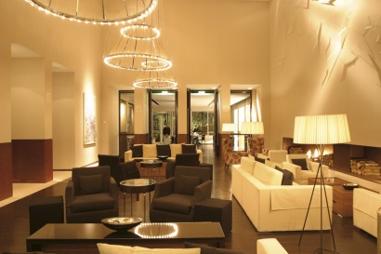
The Park Plaza is a deluxe 4 star hotel located in the heart of the city centre on Greyfriars Road, opposite City Hall and within easy walking distance to Cardiff University campuses, including Park Place, Newport Road, Corbett Road, Cathays Park and Senghenydd Road. Also within walking distance of the University of South Wales Atrium and a short taxi ride to Cardiff Metropolitan University’s compuses.

Free WiFi, free use of health club facilities and full Welsh breakfast included in all rates. Laguna Kitchen & Bar uses locally sourced Welsh produce and has won Restaurant of the Year. Outside balcony for dining.

FACILITIES:

- En-suite with air conditioning  - Tea/Coffee facilities  - TV and complimentary WiFi | - NCP car park opposite – 20% discount  - Full Leisure facilities, including 20 metre pool, 80 station gym, steam room & spa bath. 8 Elemis treatment rooms
Disability access: Fully compliant

 | Price inc. VAT | Price per room / person? | Mon- Sun?
ROOM RATES:
Single Room | £99.00 | Per room | Sun - Thurs
Double room | £109.00 | Per room | Sun – Thurs
Double room – single occupancy | £99.00 | Per room | Sun - Thurs
Executive Double for single occ | £129.00 | Per room | Sun – Thurs
Executive Double for double occ | £139.00 | Per room | Sun - Thurs
DELEGATE RATES:
Day Delegate | £32.00 | Per person
24hr Delegate | £165.00 | Per person

Day rate includes wifi, main room hire, unlimited tea and coffee, two course luncheon, OHP, screen, flipchart and LCD projector. Natural daylight in most meeting rooms.

24hr rate include the above plus 3 course TDH dinner, room and full breakfast.

HOTEL: St. David’s Hotel & Spa Tel: 07507 554009
Havannah Street Reservations: 029 2045 4045
Cardiff, CF10 5SD Conference: 029 2045 4045 Contact: Laura Lewis
Email: laura.lewis@principal-hayley.com
Web: http://www.principal-hayley.com
Owner : Principal Hayley No. of rooms: 142
Rating: 5 star No. of conference rooms: 8
Quote Ref: Cardiff University

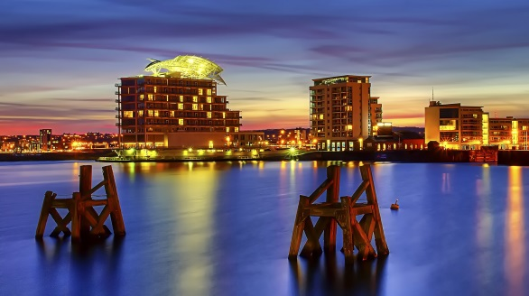
DETAILS:

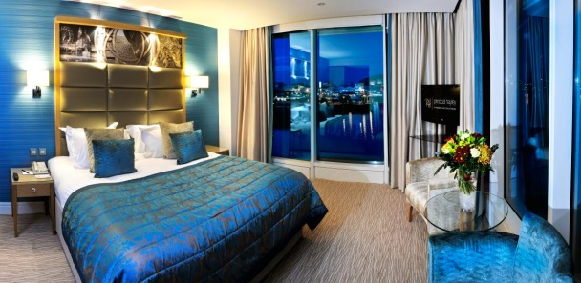
Situated on the waterfront of Cardiff Bay, the St. David’s Hotel & Spa is a striking Cardiff landmark. Dynamic and contemporary in style, the building incorporates a glass-backed atrium from floor to ceiling, giving a vision of space and natural light. Hosts an on-site spa and restaurant as well as on-site parking. Cardiff International Airport is just 13 miles away, Cardiff Central Station within a short taxi ride or train ride from Cardiff Bay station (five minute walk from the hotel) and easy access to University campuses.

FACILITIES:

- All bedrooms en-suite  - Tea/Coffee/Ironing facilities  - TV and WiFi  - Full buffet breakfast  - Fully compliant disability access | - Hotel car park with 55 spaces charged at £15 for 24hrs. Also NCP car park adjacent.  - Full Leisure facilities, including pool, gym, hydro pool and spa treatments.  - Business centre and Tempous at Tides Restaurant

 | Price inc. VAT | Price per room / person? | Mon- Sun?
ROOM RATES:
Double room – single occupancy | £89.00 | Per room | Sun – Thurs
Double room – double occupancy | £101.00 | Per room | Sun - Thurs
DELEGATE RATES: | From:
Day Delegate | £39.00 | Per person
24hr Delegate | £149.00 | Per person

University rates also include 20% discount off pre-booked spa treatments and food purchased in Tempuos at Tides (Sun-Thurs).

HOTEL: Swansea Marriott Tel: 01792 634866
Maritime Quarter Reservations: 01792 642020
Swansea, SA1 3SS Conference: 01792 642020
Contact Name: Vaness Walters
Email: mhrs.swsdt.frontdesk@marriotthotels.com Web: www.swanseamarriott.co.uk
Owner Marriott Hotels International No. of rooms: 119
Rating: 4 star No. of conference rooms: 6
Quote Ref: University / Government rate

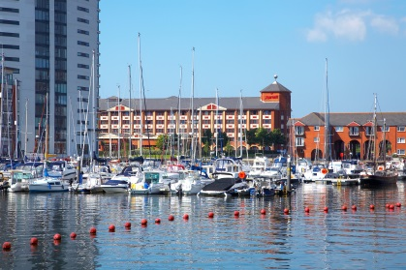
DETAILS:

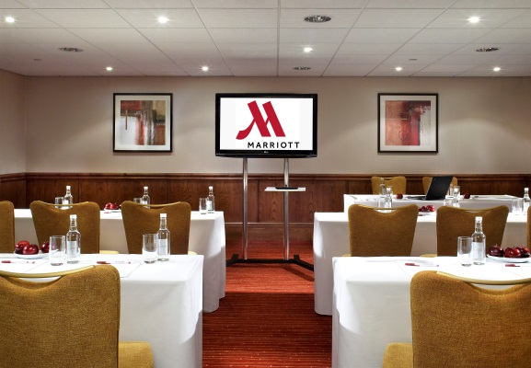
In the bustling Maritime Quarter on the enchanting Swansea Bay, the Swansea Marriott Hotel captures the charm and beauty of its Gower peninsula surroundings. A gentle stroll to the city centre complete with its lively markets and attractions, surrounded by the very best of Wales' golf courses, a short distance from the Liberty Stadium and Ffos Las Racecourse, the Swansea Marriott Hotel has appeal for all. Experience a superior level of service and the warmest of Welsh welcomes. Our spacious guest rooms offer supreme comfort and functionality. Make use of your in-room workspace, before unwinding in our Leisure area, with mini gym, pool, whirlpool and sauna. The hotel restaurant serves local produce complimented with fine wine, which follows through to our extensive room service menu. The Swansea Marriott Hotel has an impressive Conference and Banqueting facility, complemented by expert catering. Whether you're on business or a relaxing break, the Swansea Marriott is the ideal venue.

FACILITIES:
- All bedrooms en-suite  - Tea/Coffee facilities  - TV and WiFi | - Car park, complimentary on site  - Full English breakfast  - Full Leisure facilities
Disability access: Fully compliant

 | Price inc. VAT | Price per room / person? | Mon- Sun?
ROOM RATES:
Single Room | £99.00 | Per room | Y
Double room, single occupancy | £119.00 | Per room | Y
Double room | £119.00 | Per room | Y
Twin room (2 doubles) | £119.00 | Per room | Y
DELEGATE RATES:
Day Delegate |  | Per person
24hr Delegate |  | Per person

Please contact the hotel Conference Office to discuss your requirements and a full quote.

HOTEL: Vale Resort Tel: 01443 665808 Hensol Park Reservations: 01443 667800 Option 1 Hensol Conference: 01443 665808
Vale of Glamorgan, CF72 8JY Contact Name: Linda Taylor
Owner Vale Resort No. of rooms: 143
Rating: 4 star No. of conference rooms: 14
Quote Ref: Cardiff University

DETAILS:

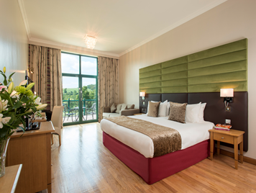
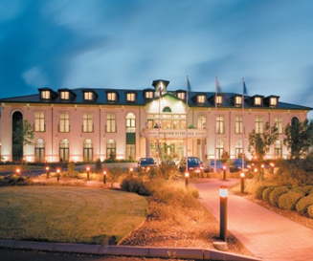
Modern Country Hotel situated just a 5 minute drive from the M4 Motorway, junction 34. The Vale Resort has 14 multi-functional meeting rooms, 143 double or twin bedrooms for single or double occupancy. A fully equipped gym plus 20 metre pool, Wales’ largest Health Spa and 2 Championship Golf Courses. AA Rosette Restaurant. Charity balls and dinners for up to 400 people.

Hensol Castle (see also Conference list) – to host exclusive meeting and events up to 200 people.

FACILITIES:
- All bedrooms en-suite, many with views  - Award winning restaurant  - 2 championship golf courses  - 19 treatment room spa | - Extensive leisure facilities  - Free onsite parking  - Free wifi  - Disability access – full compliant

 | Price inc. VAT | Price per room / person? | Mon- Sun?
ROOM RATES:
Double room, single occupancy | £80.00 | Per room | Y
Double/Twin Room | £90.00 | Per room | Y
DELEGATE RATES:
Day Delegate | £45 | Per person
24hr Delegate | £145 | Per person

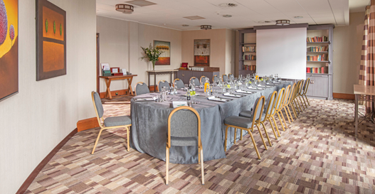
Day Delegate rate includes:
Hire of main conference room
1 Serving of tea/coffee with Danish Pastries
Finger buffet served with tea/coffee
2 servings of tea/coffee with biscuits
Screen, flipchart and pens
Conference stationery & name cards
Cordials, mineral water, sweets
FREE parking
24 Hour rate includes all the above with:
Overnight luxury accommodation  Full Welsh Breakfast | Dinner – menu A included in 24hr rate  Complimentary use of leisure facilities

